**KDM PROJECT SCRUMDO PART**

Creating organization with name KDM under which we will do project

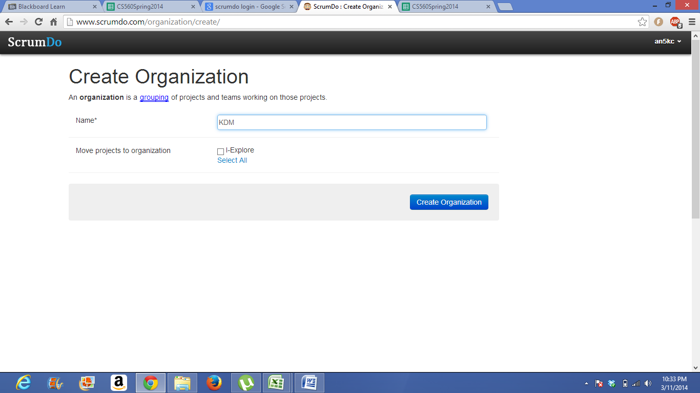

creating kdm project under KDM Organization

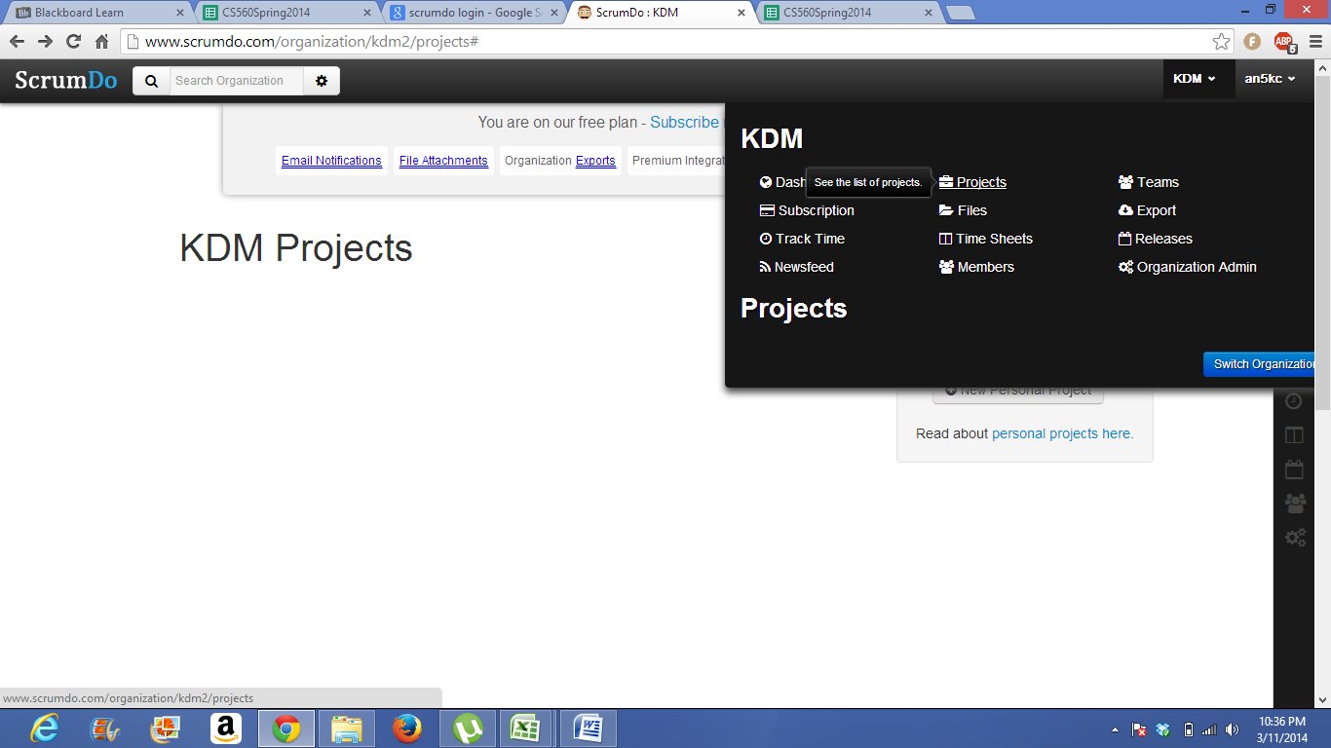

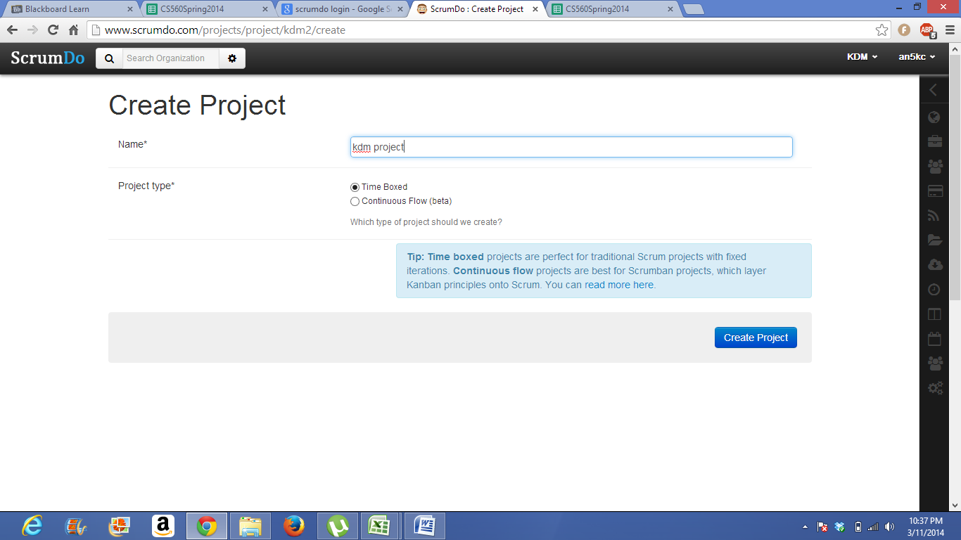

Giving permission for the members (adding members)

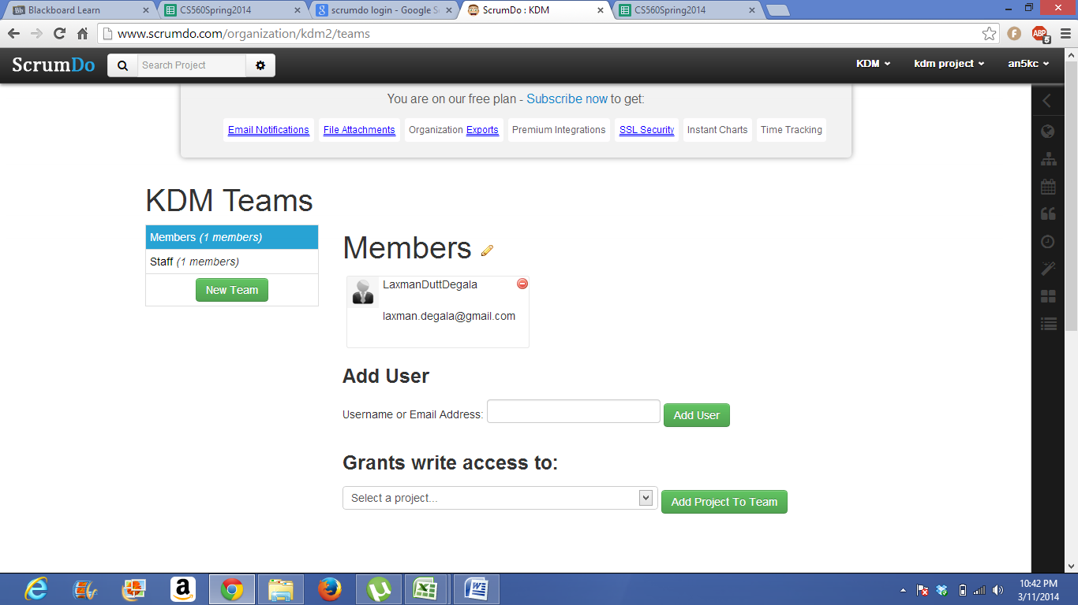

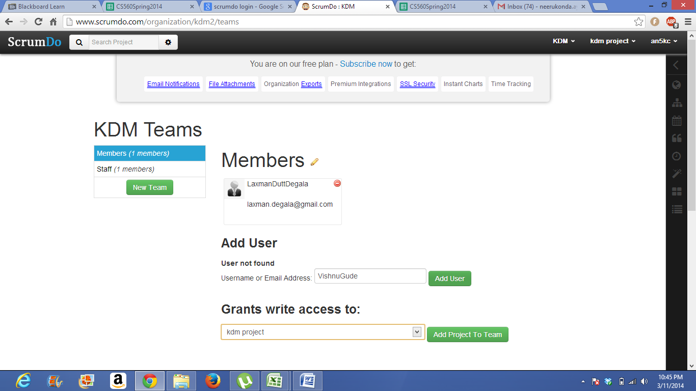

SCRUMDO free version gives permission for three members in a group so showing pending member permission.

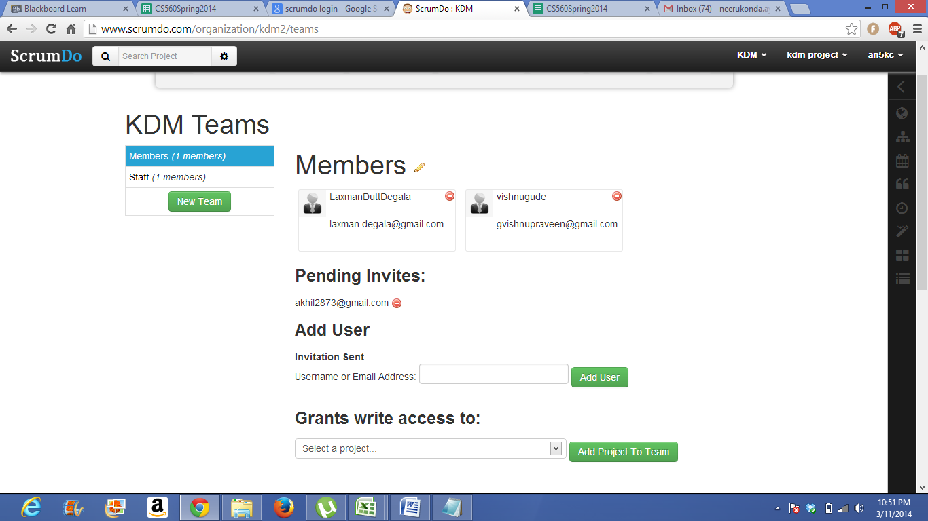

members of the project

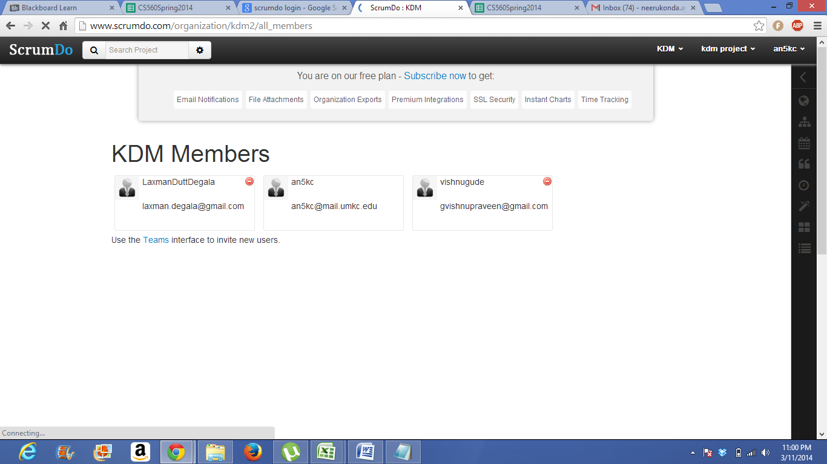

Still further study is to be needed in order to create iterations and work assignments so slides related to iteration planning will be shown as soon as possble.